## Getting Started with Power Apps Studio

**Lab Time**: 60 minutes

**Lab Folder**: C:\Student\Modules\01_GettingStarted\Lab

**Lab Overview**: This lab covers how to get up and running with the Power Platform by creating a new Microsoft 365 tenant with trial subscriptions to Office 365, Power Apps, Flow, Power BI and SharePoint Online. The act of creating and configuring this new Microsoft 365 tenant will yield an isolated testing and development environment for building and testing the apps and components you can build with Power Apps and Flow. One valuable aspect of creating your own new Microsoft 365 tenant is that you will have Global tenant administrative permissions allowing you to create multiple Microsoft 365 user accounts for testing your apps and flows in isolation from any other existing Microsoft 365 tenant.

### Exercise 1: Setup a Power Apps Builders Environment

In this exercise, you will download a local copy of the student files from a GitHub repository named **PowerPlatformMasterClass**.

1. Launch a browser and navigate to the GitHub repository for this course at the following URL.

<https://github.com/CriticalPathTraining/PowerPlatformMasterClass>

1. You should see the home page for the repository as shown in the following screenshot.

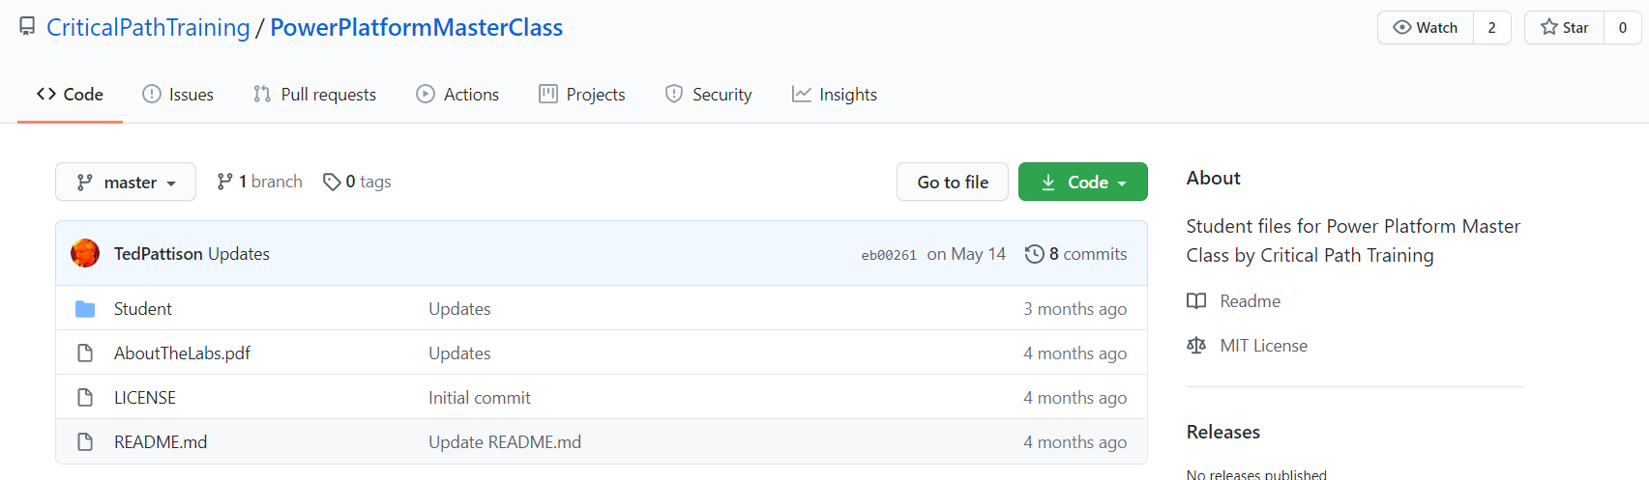

Note that you can examine the folders and the contents of individual files of this repository using the browser. However, it will be easier for you to download a local copy of the files from this repository as you work on these lab exercises.

1. Download the ZIP archive with the student files using the following URL:

<https://github.com/CriticalPathTraining/PowerPlatformMasterClass/archive/master.zip>

1. Extract the **Students** folder from the master.zip archive into a local folder on your hard drive at **C:\Student**.

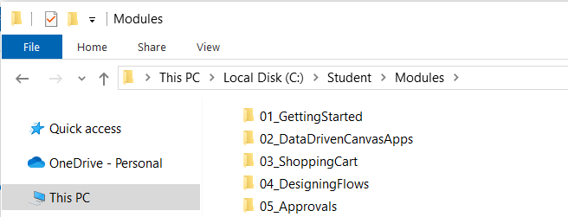

There is a child folder in **C:\Student\Modules** for each course modules containing PDF files named **Lab.pdf** and **Slides.pdf**. These files provide you with all the slides and lab exercise writeups for this training course.

### Exercise 2: Sign Up for an Office 365 E5 Trial

In this task you will create a new Office 365 trial tenant. As you work through the sign up process for this free trial, you will be asked to provide a user name and a password for an Azure AD user account that will be configured as the tenant Global administrator. You will log in with this account when developing and testing applications that use Power BI embedding. However, it's a good practice that you also test your applications with standard user Azure AD accounts that have no administrative permissions. The trial tenant that you are going to create will allow you to create up to 25 user accounts with Office 365 E5 subscriptions. Remember that any user with an Office 365 E5 subscription is automatically assigned a Power BI Pro license as well.

1. Navigate to the Office 365 trial sign up web page.
   1. Launch the Chrome browser.
   2. Copy and paste the following URL into the address bar of the incognito window to navigate to the signup page.

<https://go.microsoft.com/fwlink/p/?LinkID=698279&culture=en-US&country=US>

* 1. You should now see the form you need to fill out to create your new **Office 365 E5** trial.
  2. Enter your email address and click **Next**.

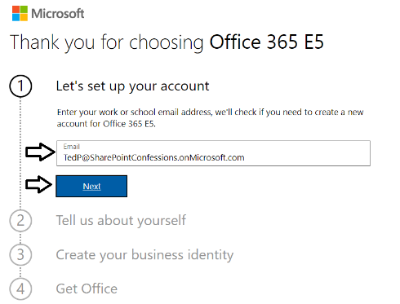

If you enter an email address for an organization account, the form provides the option to sign in. Do not click the **Sign in** button because you don't want to sign with an existing organization account. The purpose of this exercise is to create a new organizational account in a new Microsoft 365 tenant.

* 1. Click the **Create a new account instead** link.

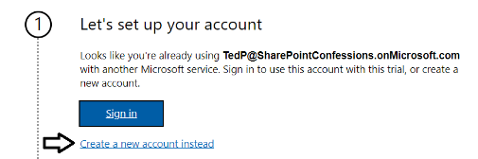

* 1. Enter your **First name** and **Last name**.
  2. Enter your mobile phone number as the **Business phone number**.
  3. Provides values for **Company size** and **Country or region** and click **Next**.

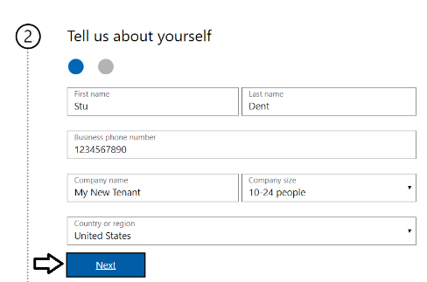

Whatever **Company name** you enter will be used as the name of the Azure AD tenant that will be created during the sign up process.

* 1. When prompted to prove you're not a robot, select the **Text me** option and ensure Phone number of for your mobile phone.
  2. Click **Send Verification Code**.

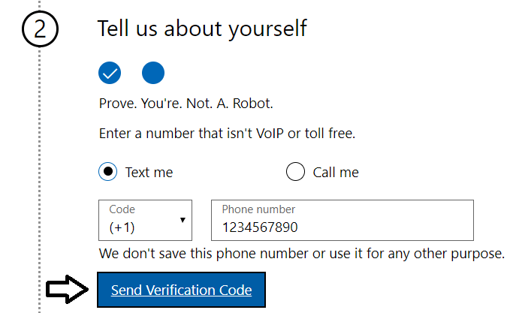

* 1. Retrieve the access code form your mobile device and use it to complete the validation process.

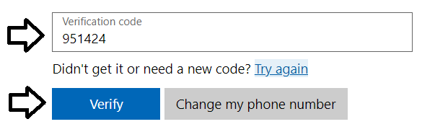

* 1. In the **Create your business identity** step, locate the textbox into which you will enter a domain name.

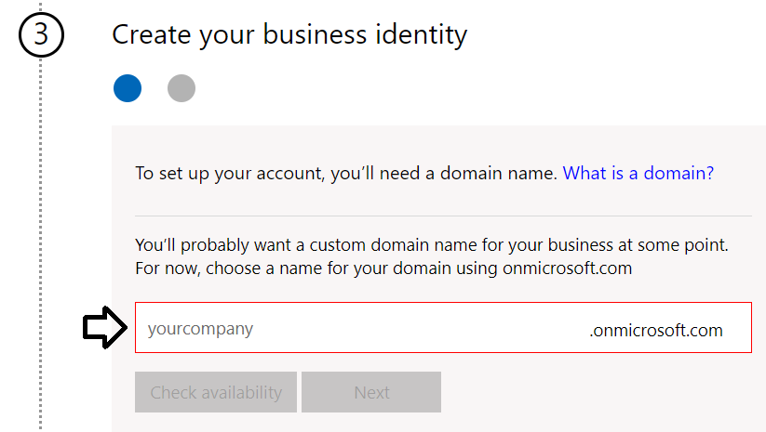

Note that the company name you enter in this textbox will be used to create an Internet domain name for a new Microsoft 365 tenant. For example, if you were to enter a company name of **cptstudent**, it would result in the creation of a new Office 365 tenant within a domain of **cptstudent.onMicrosoft.com**. The user name you enter will be used to create the first user account which will be given global admin permissions throughout the Azure AD tenant. If you enter a user name of **Student**, then the email address as well as user principal name for this account will be **student@cptstudent.onMicrosoft.com**

* 1. Enter a domain name for your new Microsoft 365 tenant.

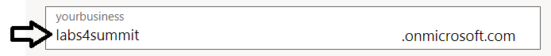

* 1. If the domain name you enter is not available, modify the domain name until you can verify that it is available.
  2. Once you have created a domain name that is available, click **Next**.

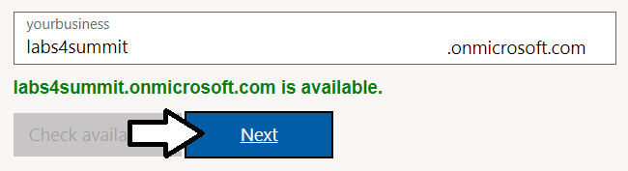

* 1. Enter a **Name** for your user account, a **Password** that you will remember and then click **Sign up**.

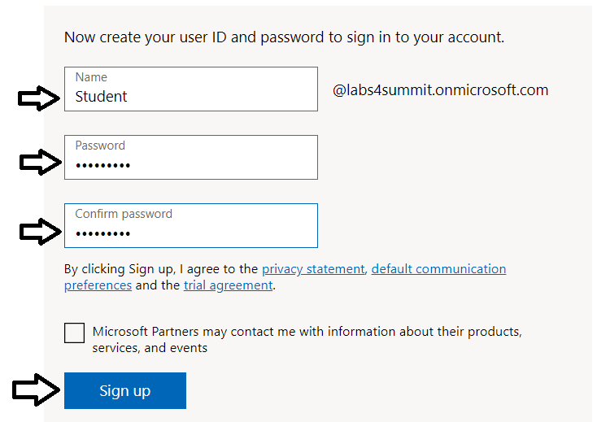

At this point, the Sign up process should begin to provision your new Microsoft 365 tenant and your new organizational account.

* 1. Once the provision process completes, take note of your new **user ID** and click the **Go To Setup** button.

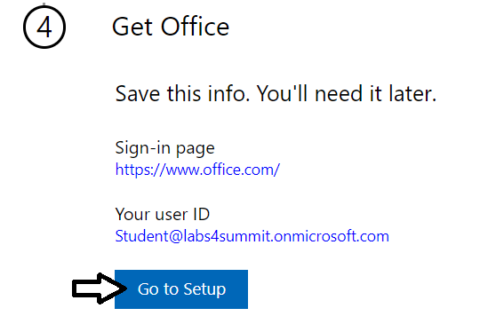

You have just created a new Microsoft 365 tenant with a 30-day trial for 25 Office 365 E5 licenses. Note that some Microsoft cloud services within your new tenant such as the Microsoft 365 admin center, Power BI, Power Apps and Flow can be accessed immediately. Other Office 365 services such as SharePoint Online, OneDrive for Business and your Outlook mailbox will not be ready immediately and can take some time to provision.

* 1. If you see the **Personalize your sign-in and email** setup page, click **Exit and continue later**.

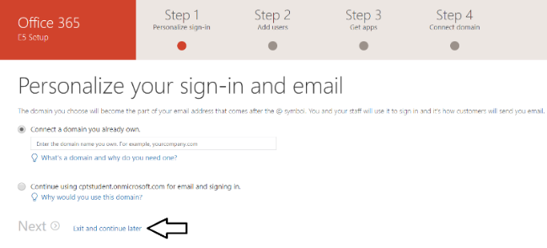

* 1. You should now be located at the home page of the **Microsoft 365 admin center**.

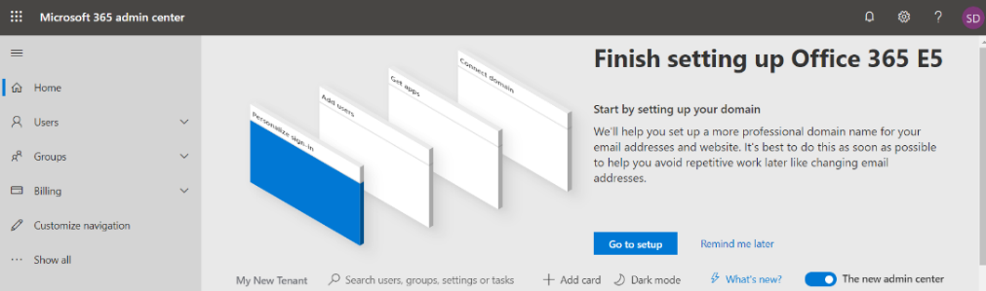

If you don’t see the home page of the **Microsoft 365 admin center**, navigate to <https://admin.microsoft.com/Adminportal>.

1. Inspect the set of active users in the current Azure AD tenant.
   1. Locate the top **Collapse navigation menu** with the hamburger icon just under the Microsoft 365 App Launcher menu.

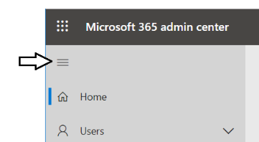

* 1. Toggle the **Collapse navigation menu** button to see how it collapses and expands the left navigation menu.

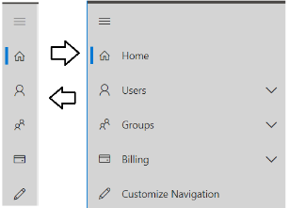

* 1. Navigate to the **Active users** view where you should be able to verify that the user account you are currently logged in as is the only user account that exists in the current tenant.

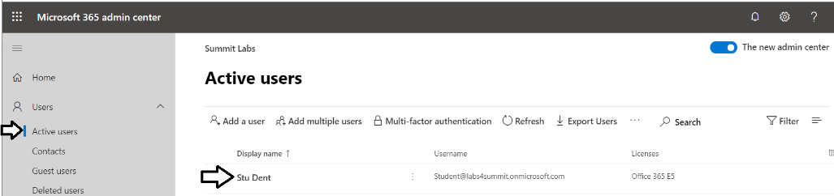

Remember that your account is global tenant administrator. You have permissions to configure any settings throughout the tenant.

1. Create a second Azure AD user account in your new Azure AD tenant.
   1. On the **Active Users** page, click the button **Add a user** button to create a new user account

. 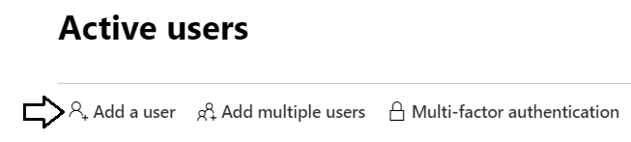

* 1. Fill in the **Set up the basics** form with information for a new user account. When creating this account, you can use any name you would like. These lab instructions will demonstrate this by creating a user account for a person named **James Bond** with a user name and email of **JamesB@labs4summit.onmicrosoft.com**.

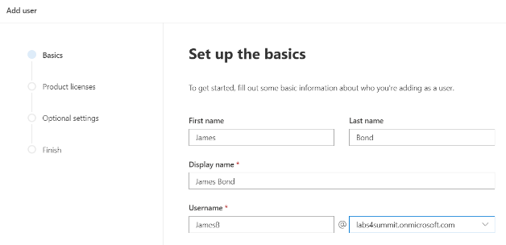

* 1. Move below to the **Password settings** section.
  2. Select the option for **Let me create the password**.
  3. Enter a password of **pass@word1** into the textbox labeled **Password**.
  4. Uncheck the checkbox for the **Require this user change their password when they first sign in** option.
  5. Click **Next**.

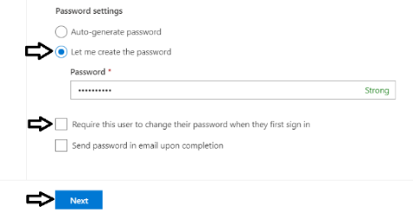

* 1. In the **Product licenses** section, make sure the **Office 365 E5** license is set to **On**.

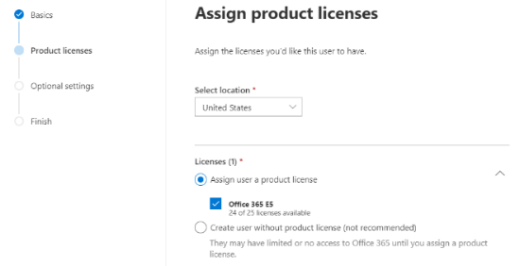

Note that the new account is usually assigned a trial license for **Office 365 E5** plan. However, it’s a good practice to check and make sure the new user has been assigned a license for **Office 365 E5**.

* 1. Click the **Next** button down below.
  2. On the **Optional settings** view, click **Next**.

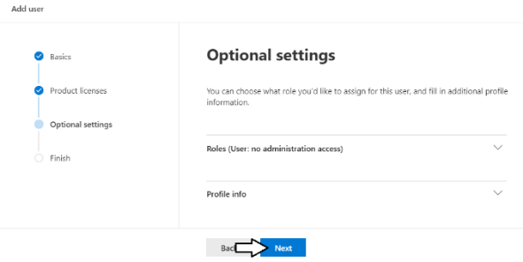

* 1. On the **Finish** view, Click the **Finish adding** button at the bottom to create the new user account.

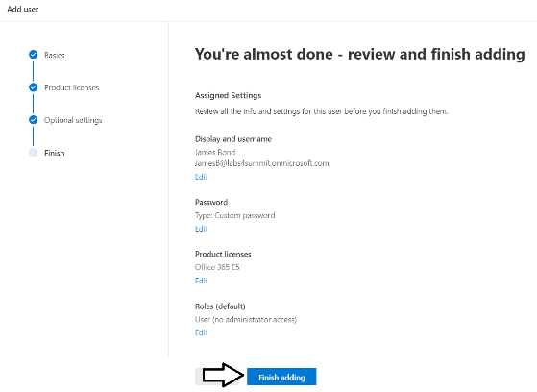

* 1. You should see the **Finish** view with a message indicating that the new user account has been created.

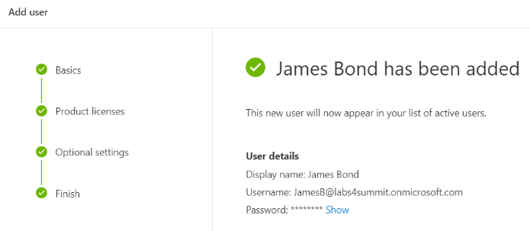

* 1. Click the **Close** button at the bottom of the **Finish** view to close the **Add User** pane on the right.
  2. Verify that the new user account has been created and is displayed along with your primary Office 365 user account.

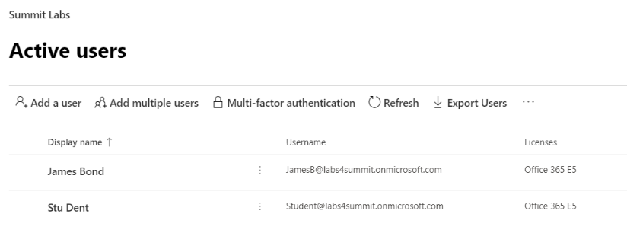

Now you have a secondary user account that does not have any administrative permissions. It's important that you test applications which use first-party embedding with standard user accounts to ensure your application doesn't require users with special permissions.

In the following steps, you will configure your new Microsoft 365 tenant by creating a new trial subscription based on Power Apps per user plan. This will provide extra licensing for Power Apps platform which goes beyond what is provided by the Office 365 E5 licensing to give you the ability to fully administrate and develop on the Power Platform.

1. Navigate to the home page of the Microsoft 365 Admin center.
2. Create a new trial subscription for **Power Apps per user plan**.
   1. Click on **Billing** in the left navigation to expand the menu items underneath.

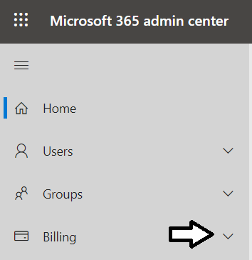

* 1. Click on the **Purchase services** navigation link.

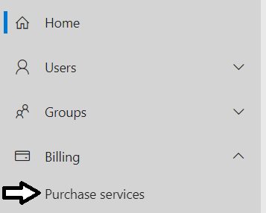

* 1. If the search box is not displayed, click **Products & services** and then click **Add subscriptions**.
  2. Type "PowerApps" into the search box to search for PowerApps subscription plans.

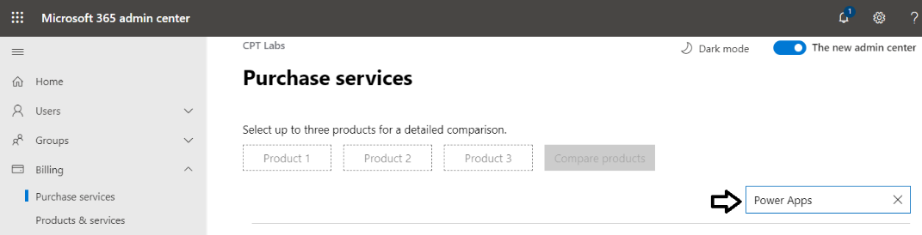

* 1. Find the subscription with the name **Power Apps per user plan** and click on it to select it.

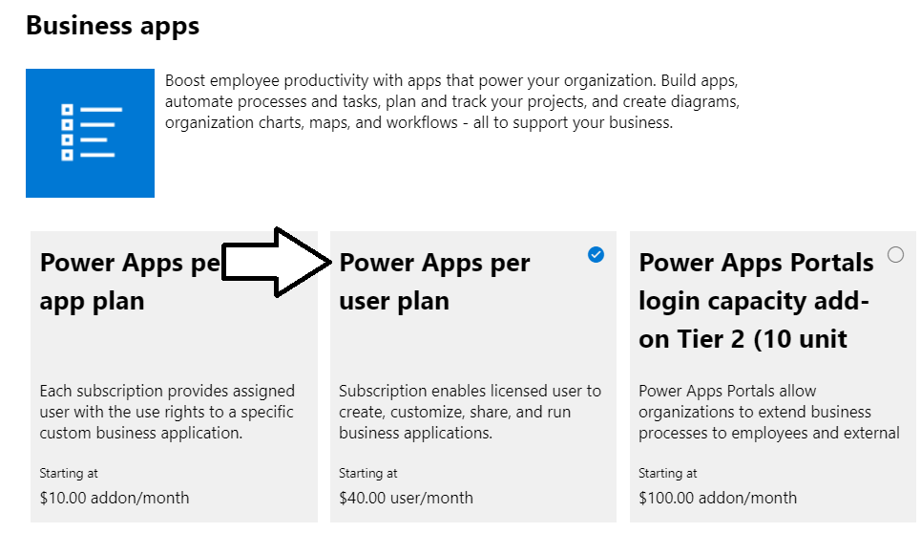

* 1. Click the **Start free trial** button

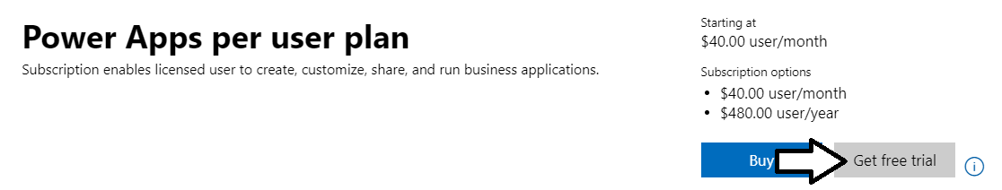

* 1. When prompted to confirm your order, click **Try now**.

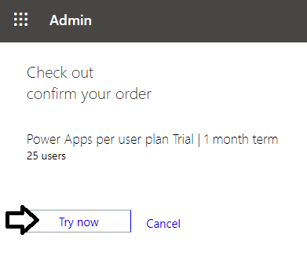

* 1. You should see an order receipt to confirm you have created the new trial subscription.

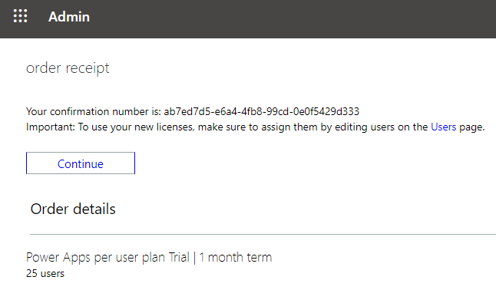

1. Configure your user account by assigning a Power Apps Plan 2 license.
   1. Navigate back to the **Active Users** page in the Office 365 Admin center.
   2. Click on your user account to edit it.

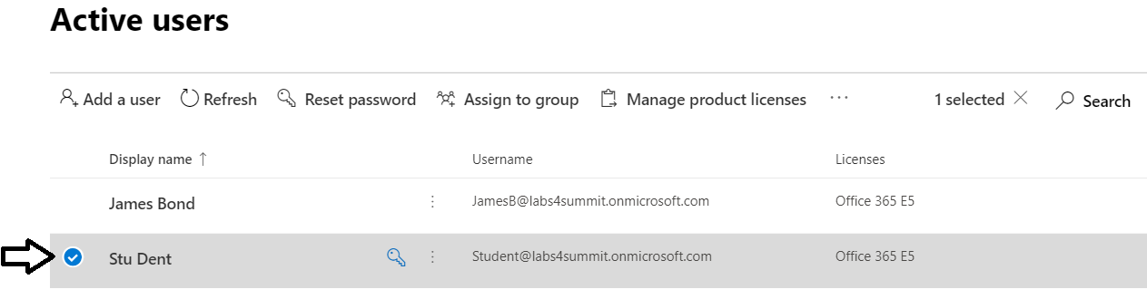

* 1. Click the **Licenses and Apps** link.

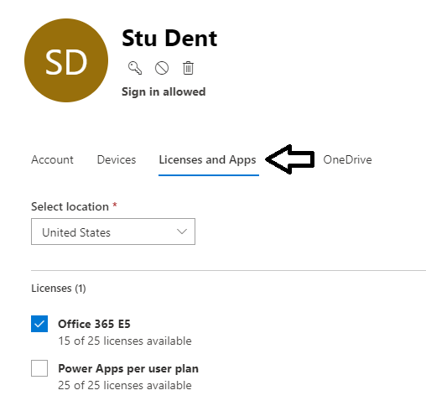

* 1. Enable the **Power Apps per user plan** subscription and then click **Save changes** below.

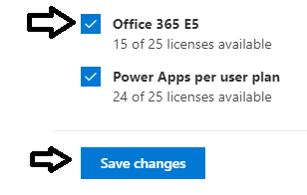

After creating a new subscription for Power Apps per user plan, it might take a minute before it shows up in the Product licenses dialog.

* 1. You should be able to confirm your user account has been configured with a **Microsoft Power Apps Plan 2** subscription.

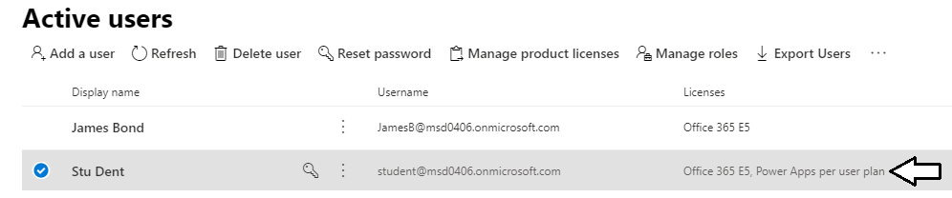

You will need the Microsoft Power Apps per user plan subscription to create a new Power Apps environment with a Common Data Service database. The Power Apps per user plan provides the licensing beyond the Office 365 license such as the ability to use premium connectors and custom connectors.

### Exercise 3: Create a Canvas App using the Start From Data Template

In this exercise you will create a new app using **Start from Data** template.

1. Upload the Excel workbook named **Expenses.xlsx** to OneDrive for Business.
   1. Using Windows Explorer, verify that there is an Excel workbook file named **Expenses.xlsx** located at the following path.

C:\Student\Modules\01_GettingStarted\Lab\Expenses.xlsx

* 1. Drop down the Microsoft 365 app launcher menu and select **OneDrive** to navigate to your **Files** collection.

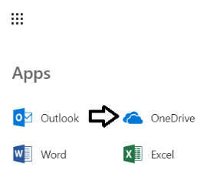

* 1. Click the **Upload** button and then select **Expenses.xlsx** to upload this file to OneDrive for Business.

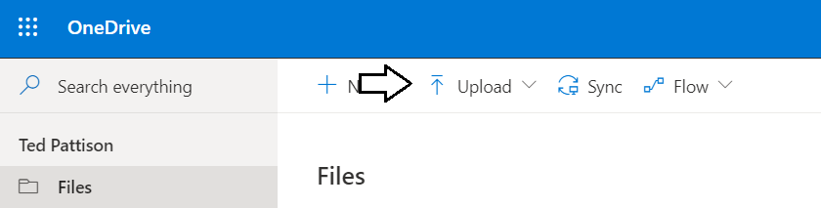

* 1. Verify that **Expenses.xlsx** has been uploaded to your **Files** folder.

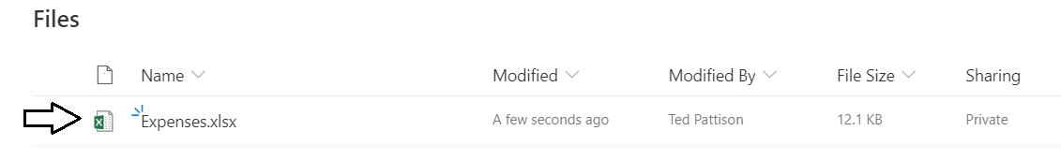

Next, you will create a new Canvas app in Power Apps Studio that will read and write to the **Expenses** table in this Excel workbook.

1. Create the new app using the data in the **Expenses.xlsx** workbook.
   1. Navigate back to the **Home** page of the Power Apps portal at <https://make.powerapps.com>.
   2. Click on the **Excel Online** tile in the **Start from data** section to begin the process of creating the new app.
   3. If a dialog box is displayed asking you to choose your country/region, select your country, e.g., United States
   4. Click **Get Started**.

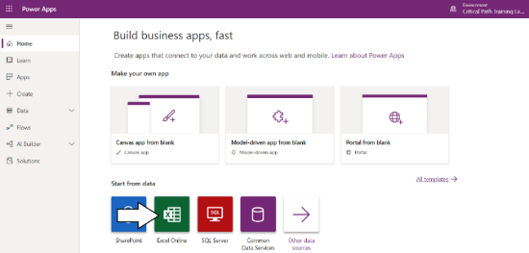

* 1. Click the **Create** button to create a new connection using the **OneDrive for Business** connector.

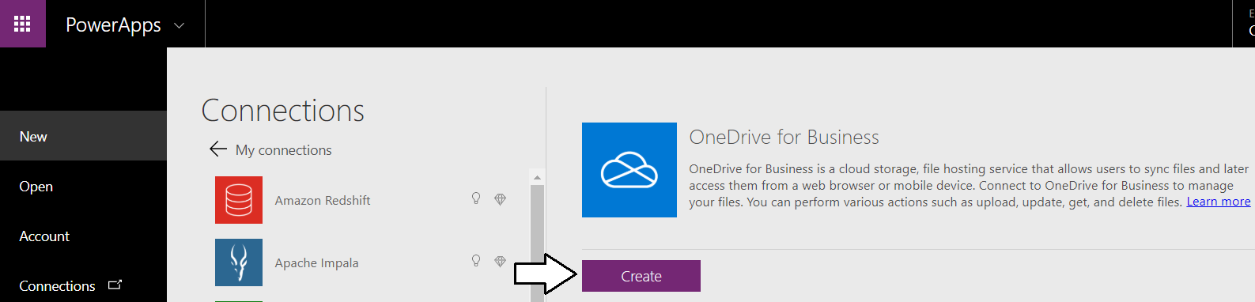

* 1. When prompted to **Choose an Excel file** on the **Connections** page, click the Excel workbook file named **Expenses.xlsx**.

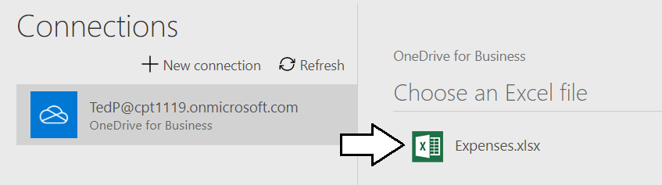

* 1. When prompted to **Choose a table** on the **Connections** page, select the **Expenses** table and then click **Connect**.

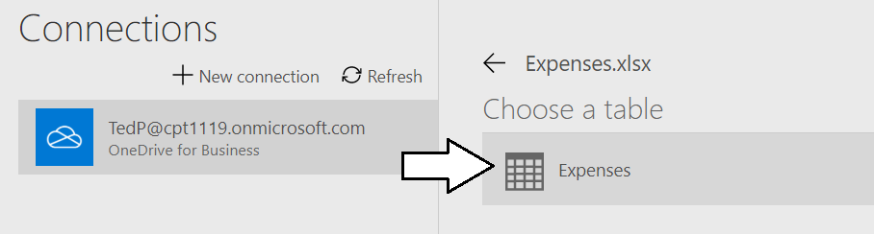

* 1. Wait while Power Apps Studio generates the starting point for your app.
  2. If you are presented with the **Welcome to Power Apps Studio** dialog, click **Skip**.
  3. Once Power Apps Studio has created the new app, it should appear as the one in the following screenshot.

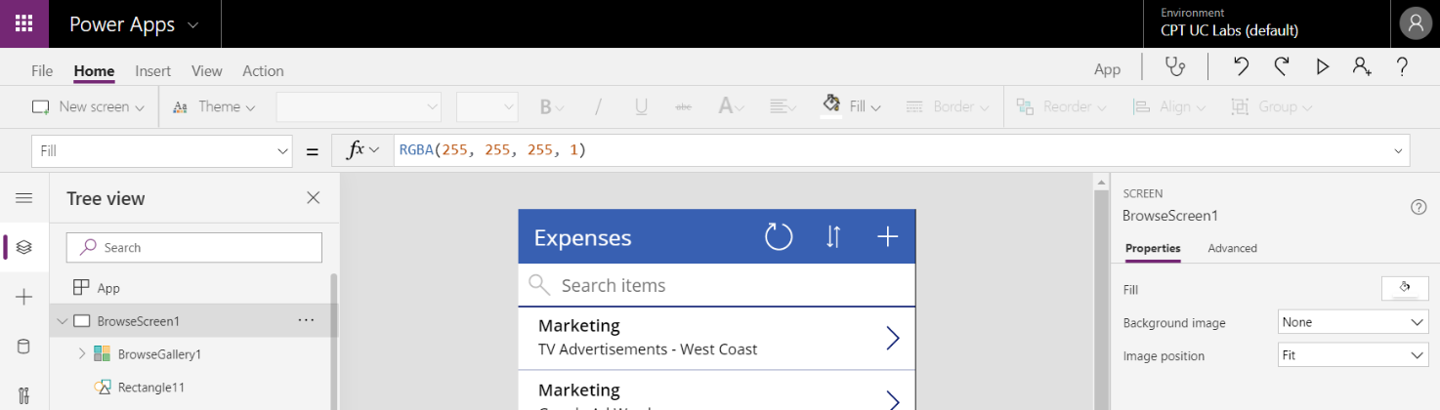

The new app has been created with three different screens. The browse screen shows many expenses at one time. The detail screen and the edit screen are both designed to display only one expense at a time.

* 1. Collapse the **Tree View** nodes for the screens named **BrowserScreen1**, **DetailScreen1** and **EditScreen1**.

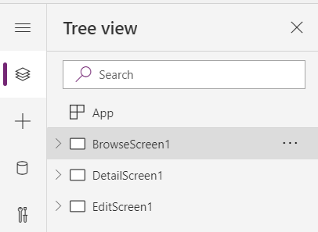

* 1. Click on **DetailScreen1** in the left navigation to inspect the detail form.

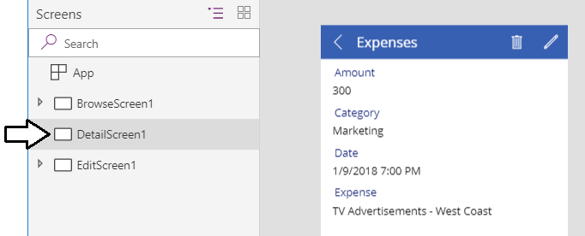

* 1. Click on **EditScreen1** in the left navigation to inspect the edit form.

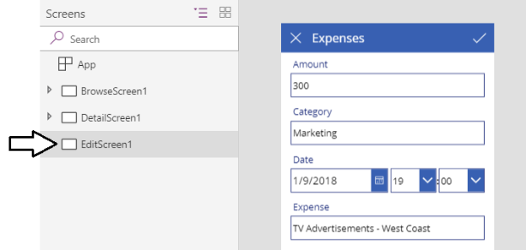

* 1. Click on **BrowseScreen1** and expand its node in the left navigation.

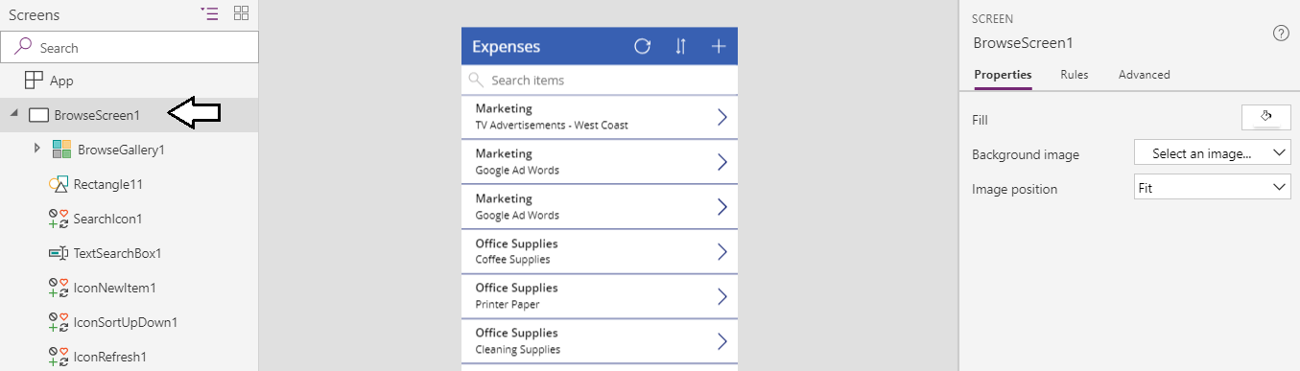

* 1. Click the **BrowserGallery1** control and then locate the Layout section in the Properties pane on the right.
  2. You should see that the **BrowseGallery1** control currently has a **Layout** setting of **Title and subtitle**.

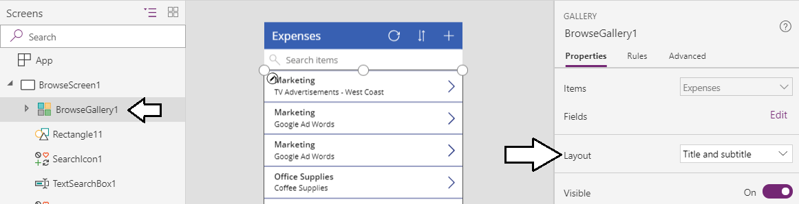

* 1. Update the **Layout** setting for **BrowseGallery1** to a value of **Title, subtitle and body**.

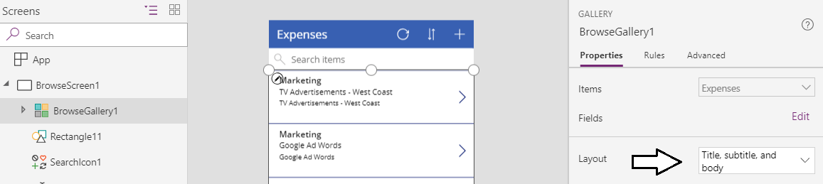

* 1. Click on the **Edit** link for the **Fields** property to Display the Data pane.

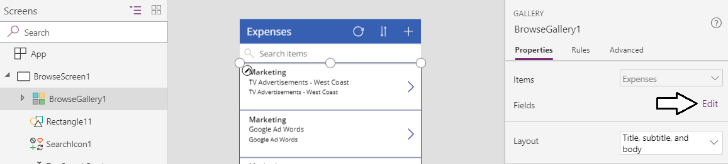

You should now see the Data pane allow you to map fields to items in the gallery template for **BrowseGallery1**. Note that the numbers at the end of template control names such as **Subtitle2** and **Title2** might be different in your environment (e.g. **Title1** or **Title3**).

* 1. Set **Body1** to the **Amount** field.
  2. Set **Subtitle2** to the **Category** field.
  3. Set **Title2** to the **Expense** field.

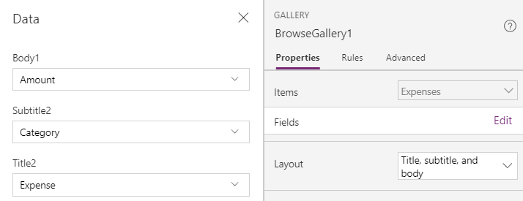

* 1. Close the Data pane by clicking the x in the top right corner.
  2. The browse screen should now display its fields ordered by **Expense**, **Category** and **Amount**.

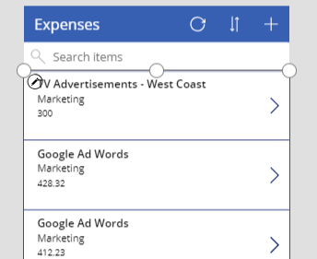

1. Test the app by starting it up and testing the search functionality.
   1. Click the Start button with the arrow icon to launch the app for testing.

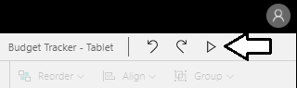

* 1. The app should start and appear as shown in the following screenshot.

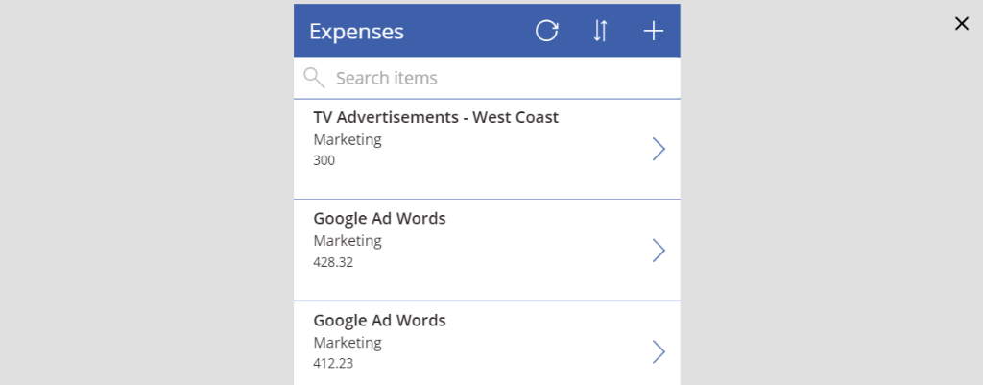

* 1. Test search functionality by typing the word “Cleaning” in the search box.

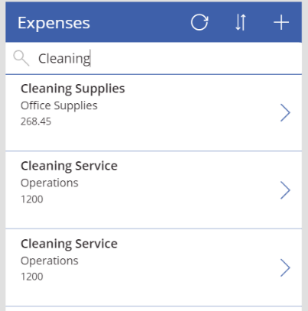

* 1. Try a different search by typing the word “Coffee” into the search box.

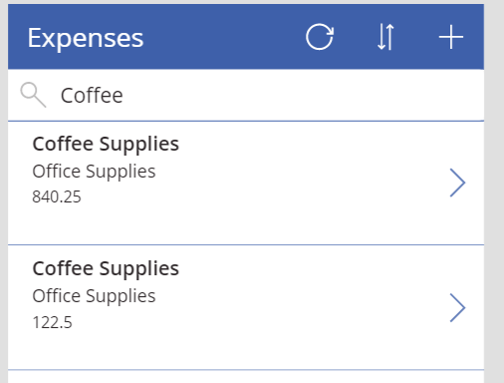

* 1. Once you have tested the search functionality, stop the app by clicking the button with the **x** icon at the top right.

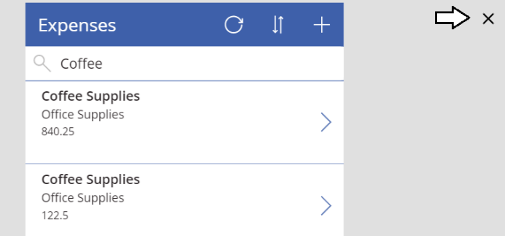

1. Configure the formatting of the expense **Amount** field.
   1. Select the textbox named **Body1** which displays the **Amount** field for each expense. You should be able to see that the **Text** value of this textbox currently configured with a formula which is **ThisItem.Amount**.

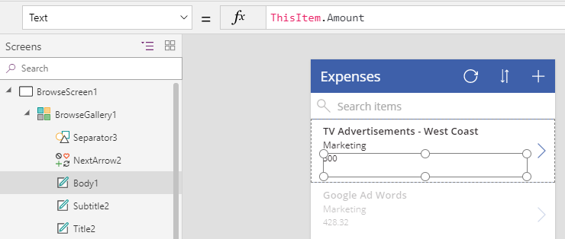

* 1. Update the **Text** property of the **Body1** textbox with the following formula.

Text(ThisItem.Amount, "$#,##0.00")

* 1. When you update the formula, it will initially match the following screenshot.



* 1. Note that after you update the formula, Power Apps Studio will automatically update the formula to include a regional prefix. For example, if your language is English and you are in the United States, it will appear as **[$-en-US]**.



* 1. The **Amount** field should now display its value with currency formatting.

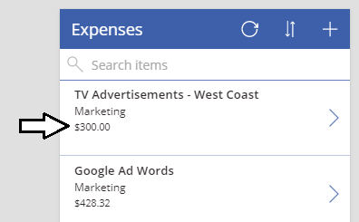

1. Configure the **Color** property of **Body1** to display **Amount** values in red when they are $500 or greater.
   1. With the **Body1** control selected, use the property drop down to display the **Color** property.

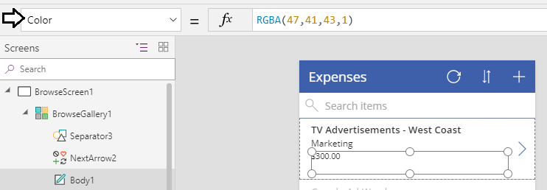

* 1. Update the **Color** property for **Body1** with the following formula.

If(ThisItem.Amount<500, Black, Red)

* 1. The formula bar should match the following screenshot.



* 1. You should now see that **Amount** values of $500 or greater are displayed with a red font.

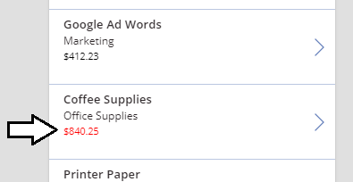

1. Modify the edit screen to streamline data entry for new expenses.
   1. Using the left navigation, move to the edit screen.

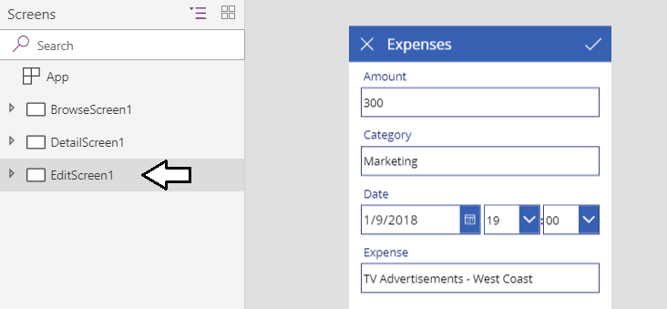

* 1. Display the **Data** pane so you can see the **Fields** collection of the edit form. At this point, the fields are sorted alphabetically.

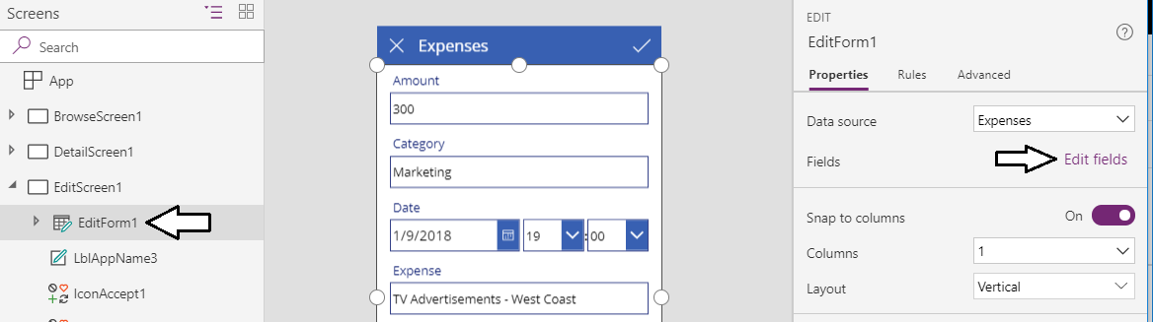

* 1. Using the mouse, rearrange the fields by moving **Expense** to the top followed by **Category**, **Date** and then **Amount**.

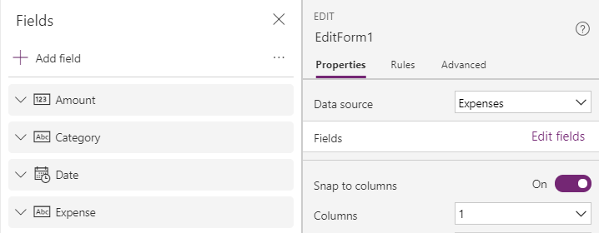

* 1. The edit screen should now display its fields using the new sort order.

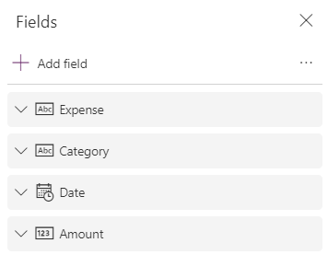

1. Update the data card for the **Category** field to provide a dropdown list with allowed values.
   1. Drop down the menu with the **abc** icon to the right of the **Category** field.

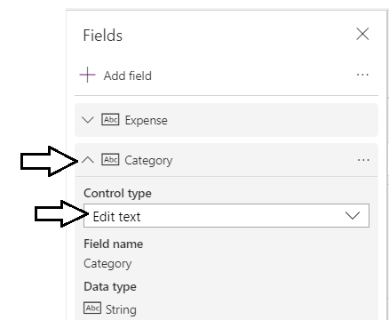

* 1. Select a control type of **Allowed Values**.

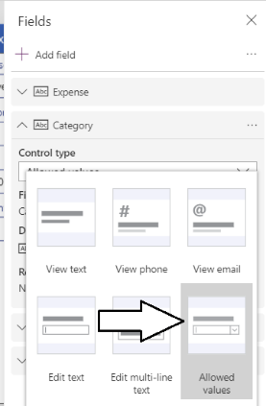

* 1. Close the **Fields** pane.

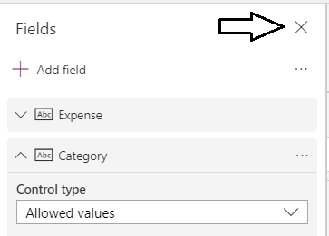

* 1. The control which displays the **Category** field should change to a dropdown menu.

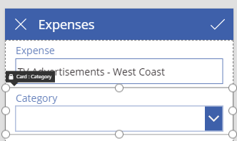

* 1. Select the dropdown menu and examine the **Items** property in the formula bar.

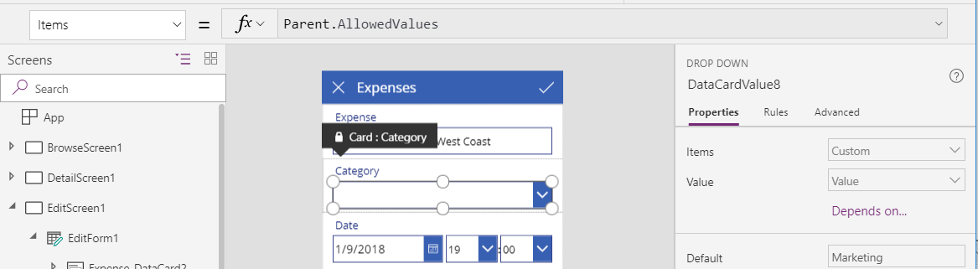

You will notice that the formula bar is read-only for the **Items** property because the data card is locked by default.

* 1. In the Advanced pane, click the Unlock to change properties button.

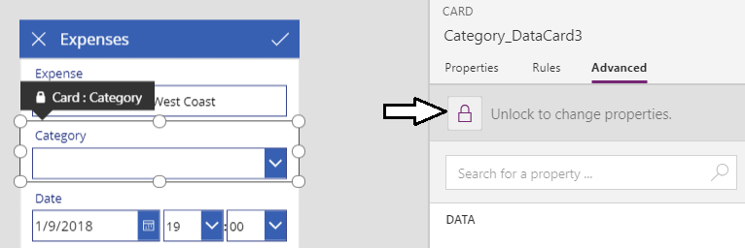

Note that the user interface experience might seem a bit strange when you click the **Unlock to change properties** button. At first it seems like nothing is happening. However, after a few seconds you should see that he **Items** property become editable.

* 1. Update the **Items** property of the dropdown list with the following formula.

["Marketing", "Office Supplies", "Operations", "Research & Development"]

* 1. The formula bar should match the following screenshot.

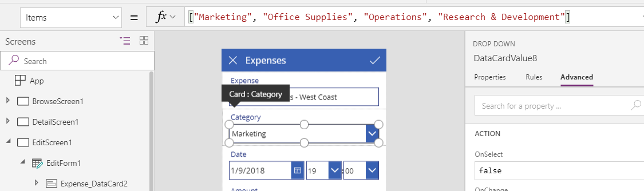

* 1. If you start the app, you should be able to test the dropdown list and verify that it provides four allowed values.

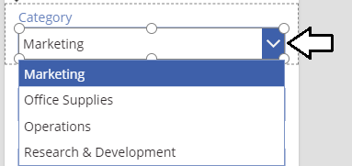

1. Update the data card for the **Date** field to make it a date-only.
   1. Select the data card for the **Date** field.
   2. In the **Advanced** pane, click the **Unlock to change properties** button for the data card for the **Date** field.

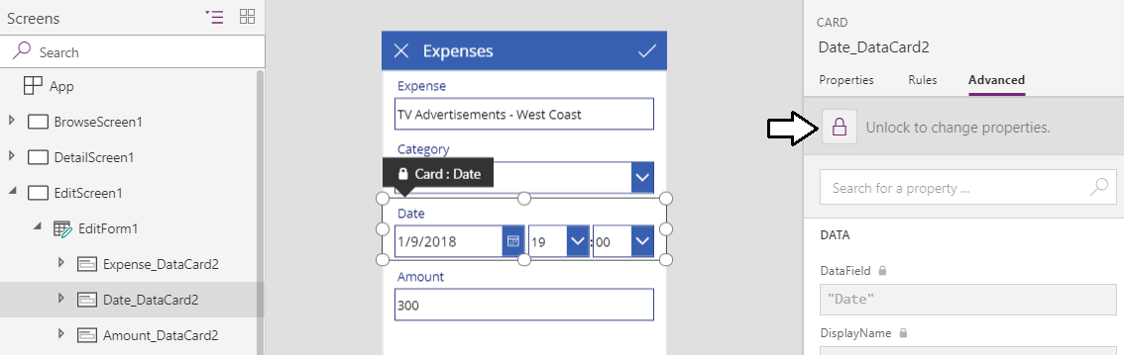

* 1. Using the left navigation, select and delete the controls named **MinuteValue1**, **Separator2** and **HourValue1**.

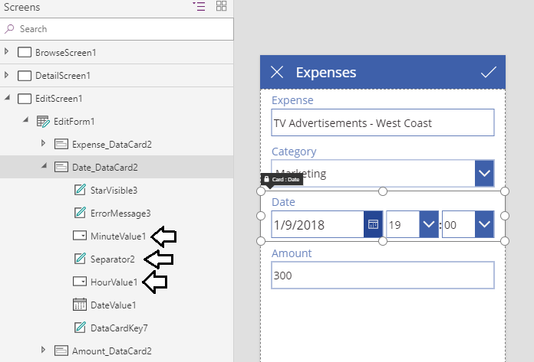

* 1. After deleting **MinuteValue1** and **HourValue1**, you will notice formula errors due to referencing deleted controls.
  2. Click on the red error icon to the left.

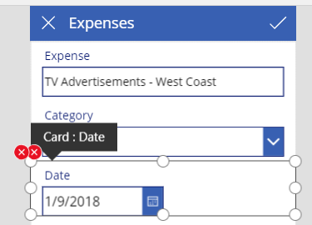

* 1. At this point, you should see the formula for the **Update** property in the formula bar.

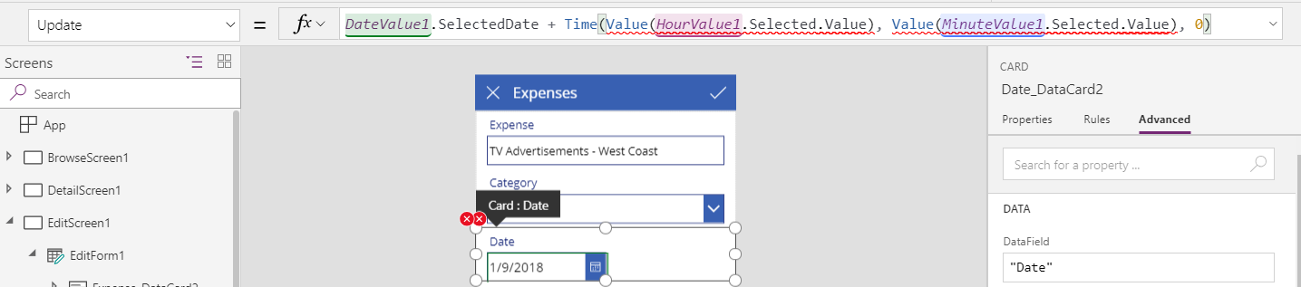

* 1. Replace the existing **Update** formula with the following formula to remove references to **HourValue1** and **MinuteValue1**.

DateValue1.SelectedDate

* 1. The formula for the **Update** property of the data card should now appear as the formula shown in the following screenshot.



* 1. Click on the one remaining red error icon to display the other formula error.
  2. You should see the **Y** property of **ErrorMessage3** contains references to the deleted control named **HourValue1**.



* 1. Replace the existing formula for the **Y** property with a value of **0** as shown in the following screenshot.



* 1. At this point, you should no longer see any error indicators.

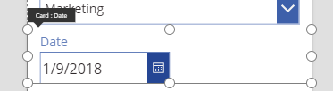

* 1. Select he **DateValue1** control and examine its **Width** property.

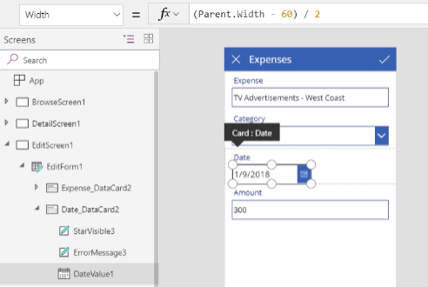

* 1. You should see that the formula of the **Width** property has the following value.

(Parent.Width – 60) / 2

* 1. Update the formula of the **Width** property to the following formula.

Parent.Width – 60

* 1. Your formula bar should match the following screenshot.



* 1. The **DateValue1** control should expand to the same width of the other input controls on the edit screen.

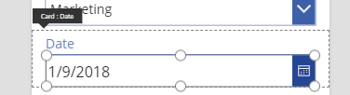

1. Update the **DataTimeZone** property of **DateValue1**.
   1. Inspect the **DateTimeZone** property of the **DateValue1** control. Its current value should be **Local**.



* 1. Update the **DataTimeZone** property to a value of **DataTimeZone.UTC** as shown in the following screenshot.



* 1. All the dates displayed on the edit screen should now move ahead by one day and display their proper value.

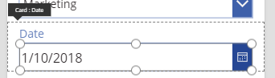

The problem with date values in the Local format is that they are offset by the difference between Greenwich Mean Time and your local time zone. For example, if you are in Eastern Daylight Time (EDT), the date of **January 10, 2018** is displayed with a 5-hour offset which is **January 9, 2018 at 7:00 PM**. By setting the **DataTimeZone** property to **UTC**, you are effectively removing the offset and the dates are displayed more accurately.

1. Configure the current day as the default value for **DateValue1**.
   1. Make sure the **DateValue1** control is selected.
   2. Inspect the **DefaultDate** property value for **DateValue1**.
   3. Update the **DefaultDate** property using the **Today()** function as shown in the following screenshot.



1. Test out the app by starting it and adding a new expense.
   1. Before starting the app, navigate to the screen named **BrowseScreen1**.

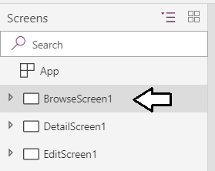

* 1. Click the Start button with the arrow icon to launch the app for testing.



* 1. When the browse screen appears, click to button with the **+** icon to add a new expense.

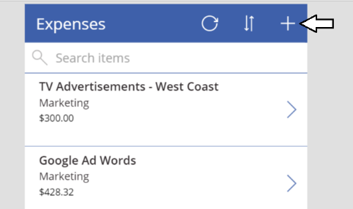

* 1. You should now see the edit form into which you can enter a new expense.

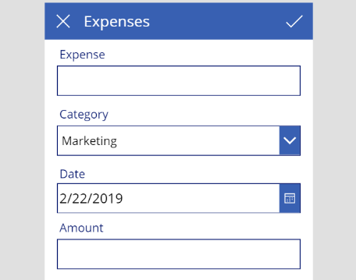

* 1. Fill in the edit form for the new expense using the data shown in the following screenshot and then click the button with the checkmark icon in the upper right to save your work.

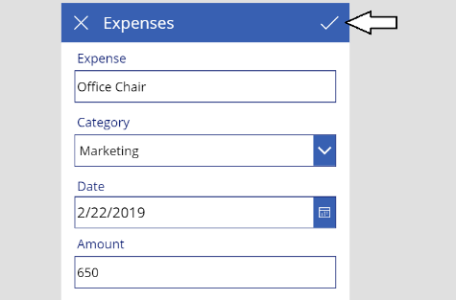

* 1. Once you have saved the new expense, you should be able to see it in the browse screen.

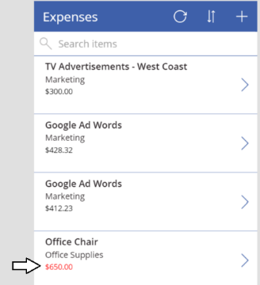

1. Save the app to the cloud.
   1. Drop down the **File** menu and click the **Settings** link.
   2. Name the app **Expense Tracker** and assign a color, icon and description as shown in the following screenshot.

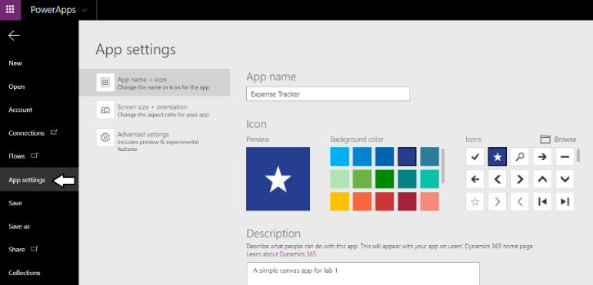

* 1. Click the **Save** link in the left navigation and then click the **Save** button in the lower, right-hand side of the screen.

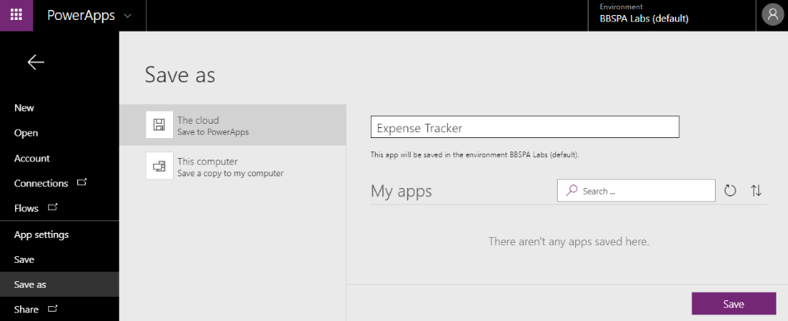

* 1. You should be able to confirm that your app has been saved.

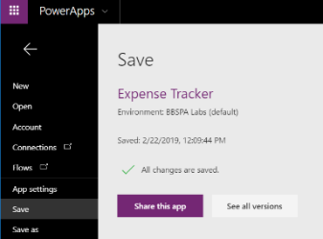

1. Examine the details of the new app.
   1. Return the Power Apps portal at <https://web.powerapps.com> and click the **Apps** link.
   2. Locate and the new app named **Expense Tracker**.

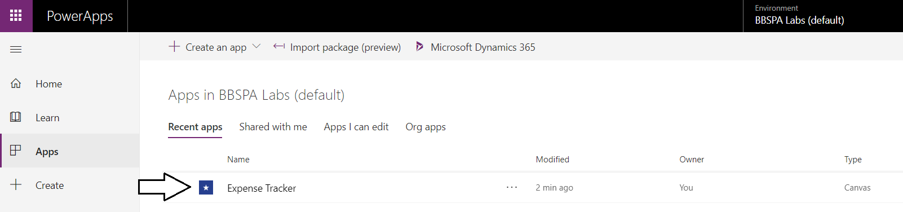

* 1. Click on the ellipse (**…**) dropdown menu to the right of **Expense Tracker** app and select **Details**.

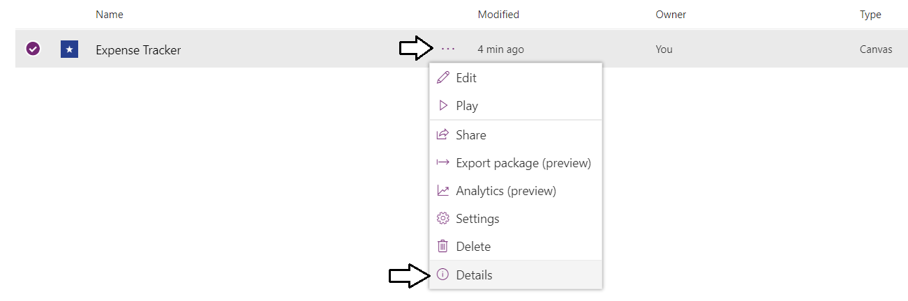

* 1. On the app **Details** page, locate the **Web link** and click on it to launch the app.

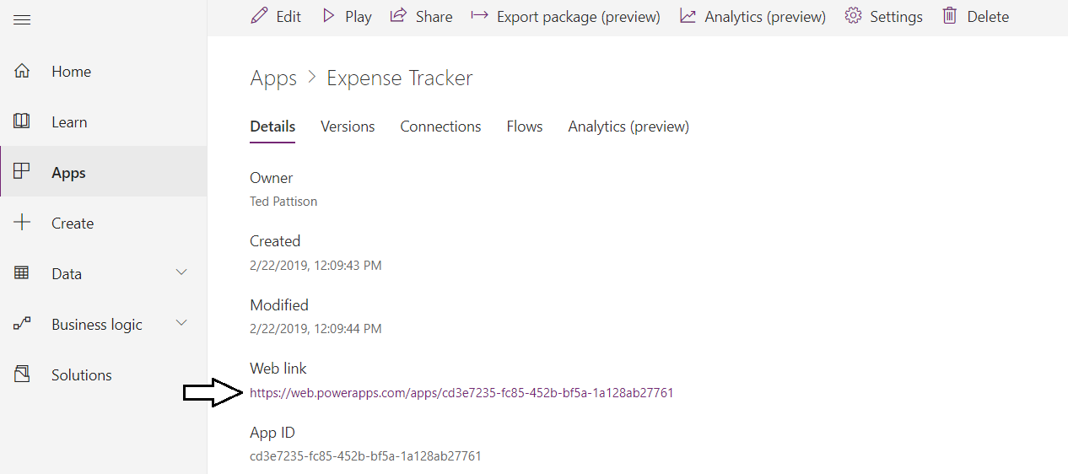

* 1. The app should start up when you click that Web link.

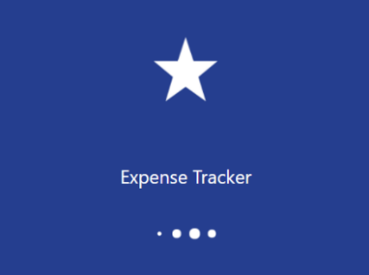

* 1. The app should now start up in the usual run mode for end users.

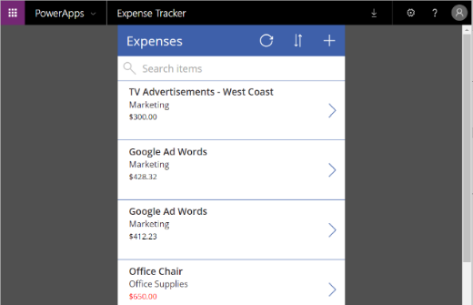

### Exercise 4: Test the Expense Tracker Application From a Mobile Device

In this exercise you will create begin by installing the native Power Apps app on your mobile device. If you have already installed the Power Apps app pn your mobile device, you can skip step 1 and move to step 2 of this exercise. If you do not have a mobile device that supports the Power Apps native app, you can skip the entire exercise and move on to Exercise 5.

1. Install the Power Apps native app on your mobile phone. This lab assumes you have a mobile phone which supports the Power Apps native app which include iPhones, Android phones and Windows 10 phones.
   1. If Power Apps app already installed on your phone, skip this step. Sign out and sign in with your new account.
   2. Navigate to the App Store for your mobile device and search for Power Apps.
   3. Locate and installed the Power Apps app on your mobile device.

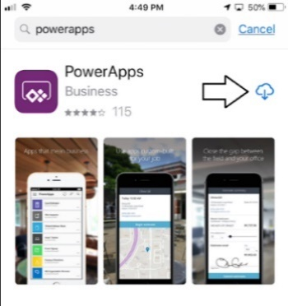

* 1. Once the Power Apps app has been installed, open it.

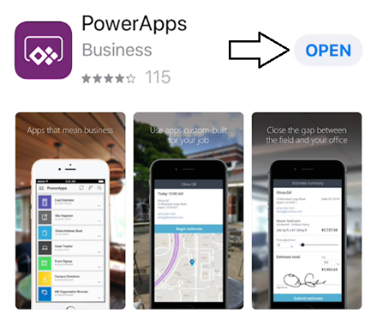

* 1. You should now see the app welcome screen..

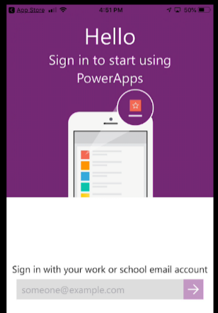

1. Sign into the Power Apps native app using the primary user account for the tenant you created at the start of this lab.
   1. Launch the Power Apps native app if it is not already running.
   2. Enter the user name (i.e. email address) of the primary user account for your new Microsoft 365 tenant.
   3. Click the purple button with the arrow to begin the sign in process.

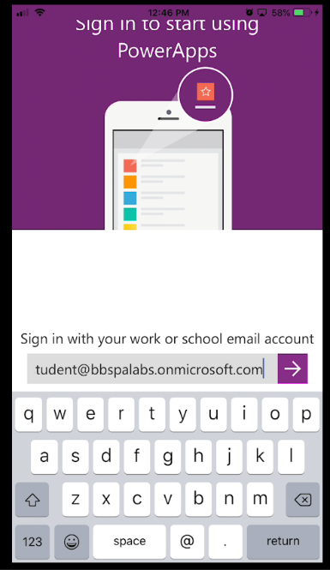

* 1. When prompted, enter your password and click **Sign in**.

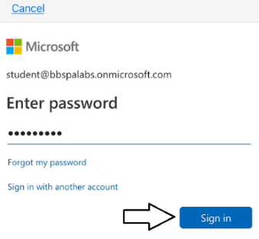

* 1. If it's the first time you have run this app, you will be prompted to allow the app to send you notifications. Click **Allow**.

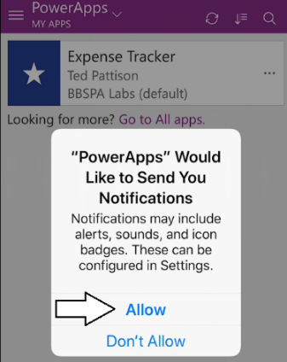

* 1. Once you have logged in, you should be able to see the Expense Track canvas app in the list of apps.

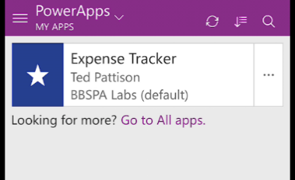

1. Open the Expense Tracker canvas app on your mobile device.
   1. Touch the Expense Tracker app in the apps list to launch it.
   2. You should see that app starting up.

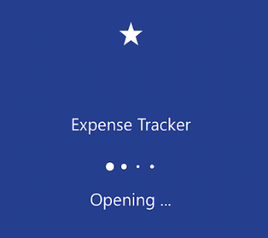

* 1. When the app opens, you should be able to view existing expenses.

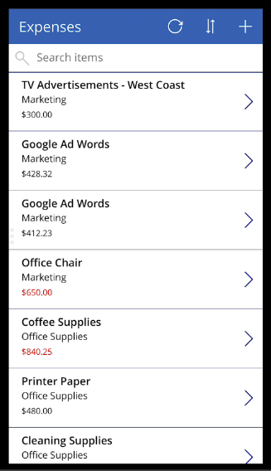

1. Use the mobile app to enter a new expense.
   1. Touch the button with the **+** sign to add a new expense.

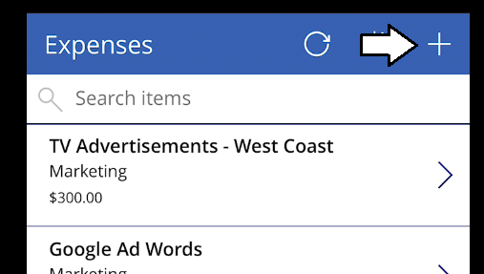

* 1. You should now see the screen for adding a new expense.

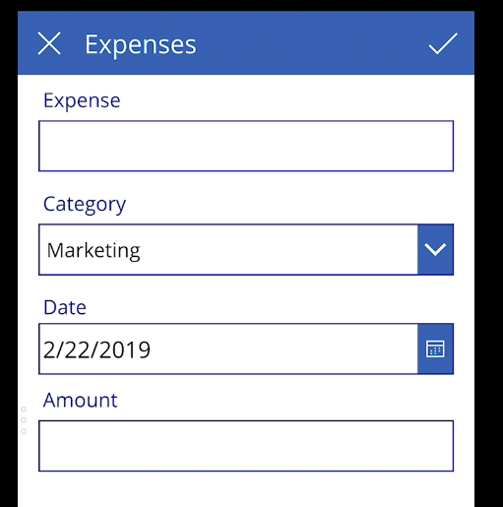

* 1. Add new expense data as shown in the following screenshot and touch the button with the checkmark to save your changes.

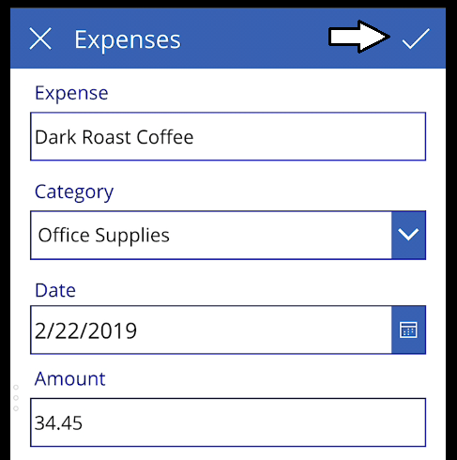

* 1. Once the expense has been saved, search for coffee and verify you can see the new expense.

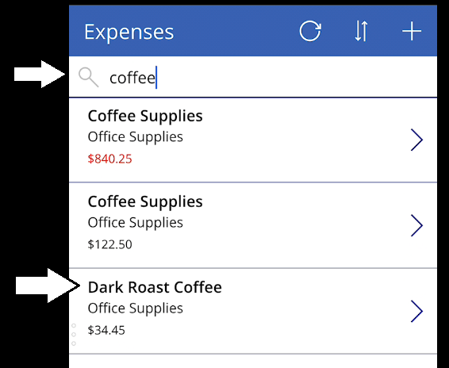

The purpose of this exercise is to ensure you can test canvas apps on your mobile device. Once you have successfully added a new expense, you can close the app on your mobile device.and move ahead to the next exercise.

### Exercise 5: Create a Canvas App using the Start from Blank Template

In this exercise you will create a new canvas app using **Canvas app from blank** template. This will give you experience creating the data binding for a canvas app without having to resort to using the **Start from data** template. In this lab you will also learn how to use the **Filter** function and the **Sort** function to manipulate data in a table. By the end, you will also work through the problems associated with a data source such as a table in an Excel workbook that does not support delegation.

1. Inspect the Excel workbook named **Cusrtomers.xlsx** located in the Student folder.
   1. Using Windows Explorer, verify that there is an Excel workbook file named **Expenses.xlsx** located at the following path.

C:\Student\Modules\01_GettingStarted\Lab\Customers.xlsx

* 1. If you have Excel installed, open up this workbook and inspect what's inside.

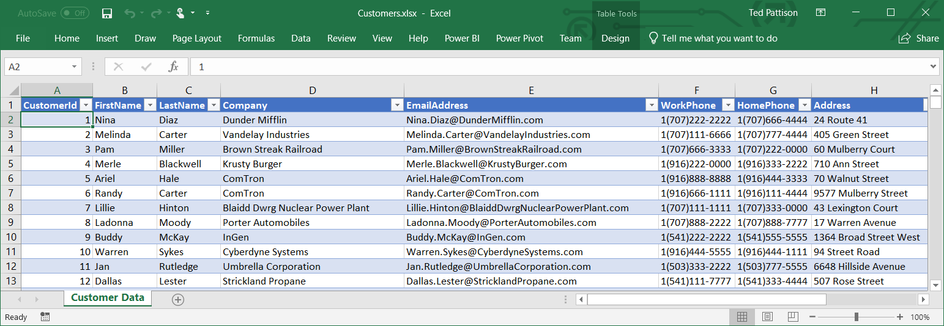

* 1. Scroll down until you reach the rows with the **CustomerId** starting with 500.

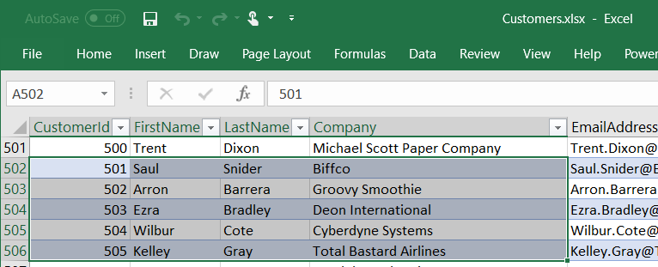

A key learning point in this exercise is gain an understanding about the behavior of data sources that do not support delegation. When a connector does not support delegation, it will only return a maximum of 500 records by default. Therefore, you will not see any customer records with a **CustomerId** over 500. Later in this lab you will search for customers with the last name "Barrera". What you will see later in this exercise is that you will not be able to find this customer with the default canvas app settings which limits the tables it returns to a maximum of 500 records.

* 1. Close the Excel workbook named **Customers.xlsx** without saving any changes and then close Microsoft Excel.

1. Upload the Excel workbook named **Customers.xlsx** to OneDrive for Business.
   1. Drop down the Microsoft 365 app launcher menu and select **OneDrive** to navigate to your **Files** collection.
   2. Click the **Upload** button and then select **Customers.xlsx** to upload this file to OneDrive for Business.
   3. Verify that **Customers.xlsx** has been uploaded to your **Files** folder.

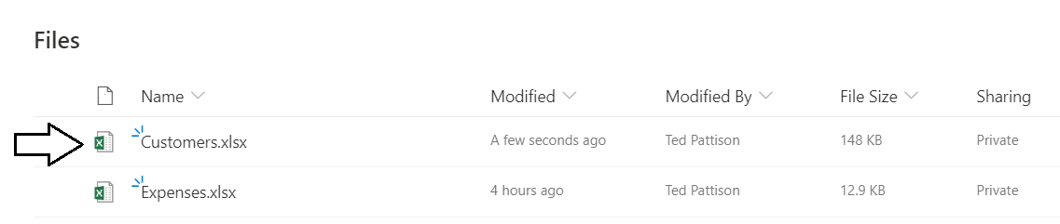

1. Create a new canvas app using the **Canvas app from blank** data template.
   1. Navigate to the Power Apps portal at [https://make.powerapps.com](https://make.powerapps.com/)
   2. Create a new canvas app by clicking the **Canvas app from blank** button.

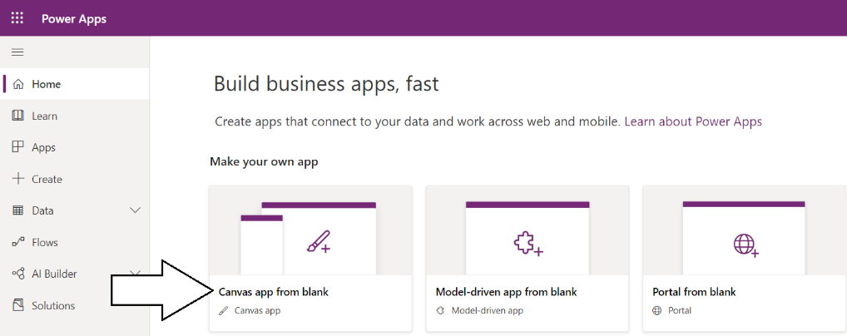

* 1. When prompted with the Canvas app from blank dialog, enter an **App name** of **Customer Search**.
  2. Make sure to select a **Format** of the **Tablet** and then click **Create**.

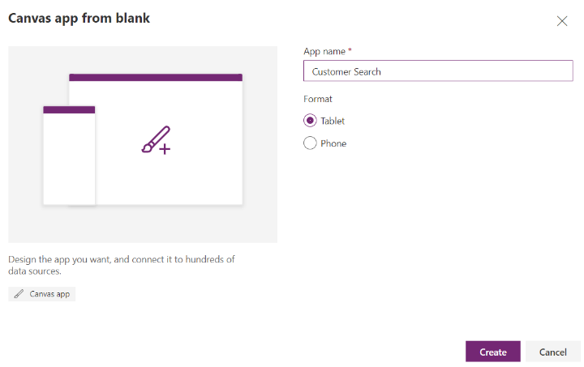

* 1. After a few seconds, you should see your new canvas app in Power Apps Studio.

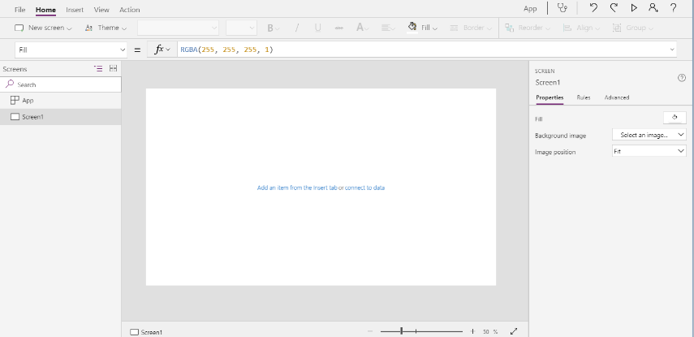

1. Configure the App settings and save your new app.
   1. Click the **File** menu and then click **Settings**.
   2. Make sure the **App name** is set to **Customer Search**.
   3. Select an icon and color of your choosing as shown in the following screenshot.

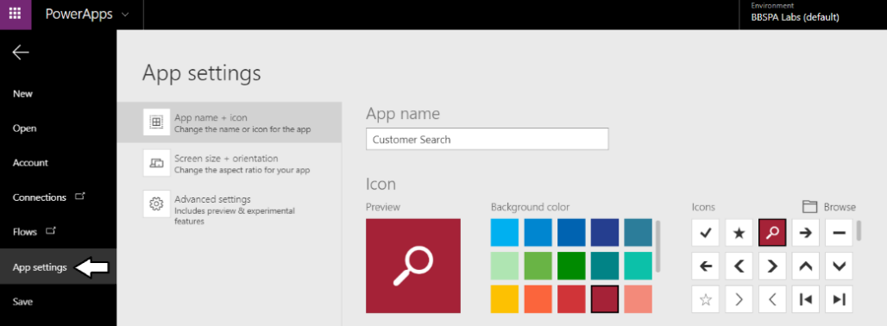

* 1. Click Save in the left navigation and then click the Save button in the bottom right corner of the Power Apps Studio window.

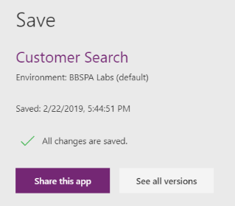

* 1. Click the back arrow at the top left corner of Power Apps Studio to return to the canvas app in edit mode.

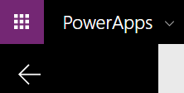

1. Update the name of **Screen1** to **Customer Search Screen**.
   1. Drop down the ellipse menu (**…**) for **Screen1** and select he **Rename** command.

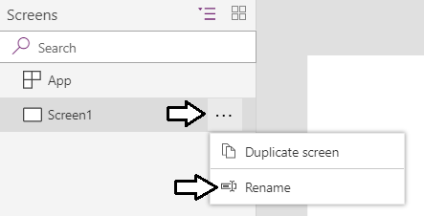

* 1. Rename the screen to **Customer Search Screen**.

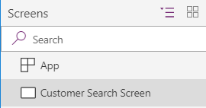

1. Add a new **Data table** control to display customer data.
   1. Navigate to the **Insert** tab in the ribbon.
   2. Click the **Data table** button to add a new Data table control to **Customer Search Screen**.

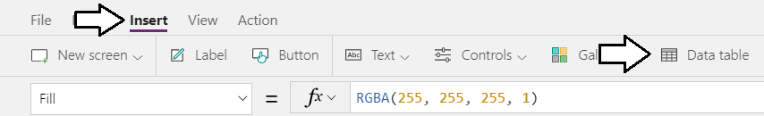

* 1. Once the Data table control has been added, inspect its properties in the Properties pan on the right.
  2. Locate the **Items** property which has a dropdown menu with the caption **Select a data source**.

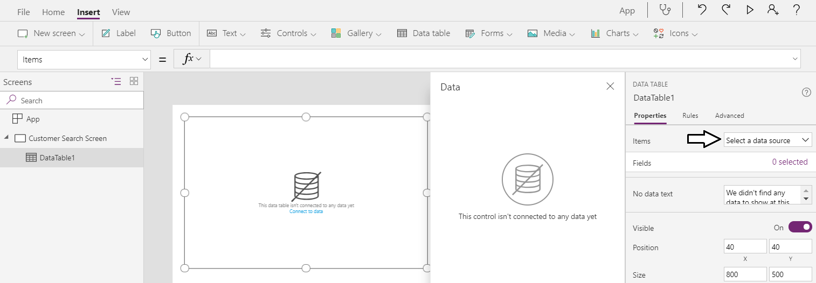

* 1. Drop down the menu for the **Items** property and select **Add a data source** to display the **Data** pane.

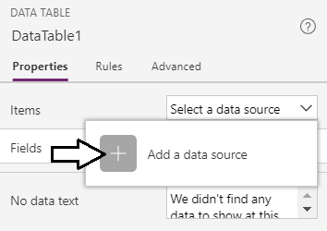

* 1. When the **Data** pane appears, select the connection named **OneDrive for Business**.

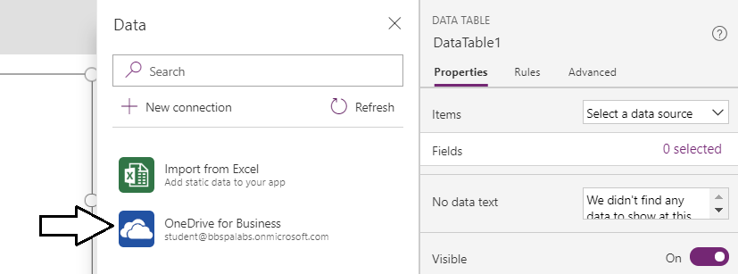

The **OneDrive for Business** connection should automatically appear because you created it when building the **Expense Tracker** app.

* 1. The **Data** pane should prompt you to **Choose an Excel file** and display the Excel workbooks at your OneDrive root library.
  2. Select the Excel workbook named **Customers.xslx**.

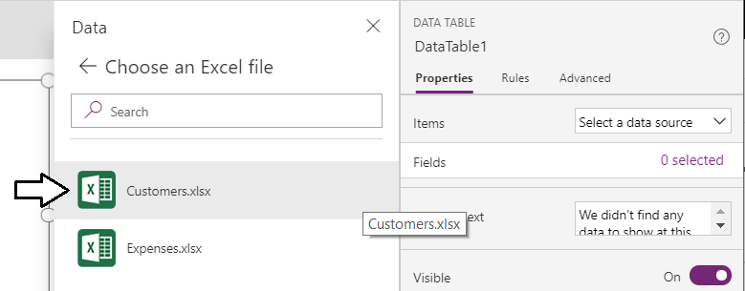

* 1. When prompted to **Choose a table**, select the **Customers** table and then click **Connect**.

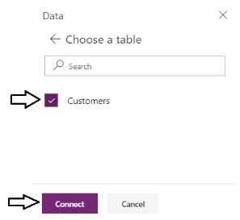

At this point, you have bound the **Customers** table to the Data table control but you have not selected any fields to display.

* 1. Inspect the **Items** property and the **Fields** property of the Data table control.
  2. You should be able to verify that **Items** property has a value of **Customers** and the **Fields** property shows **0 selected**.

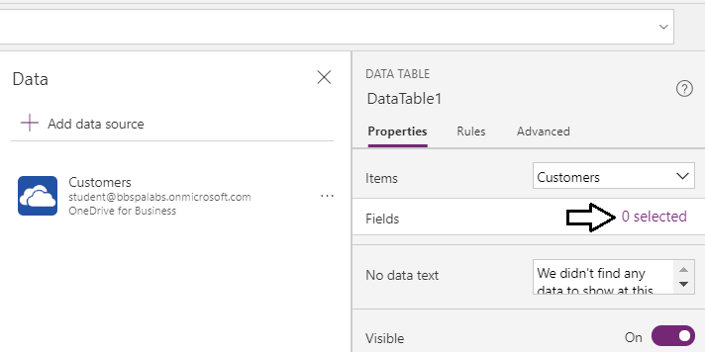

* 1. Click the link for the **Fields** property with the caption **0 selected** to display the **Fields** list in the **Data** pane.

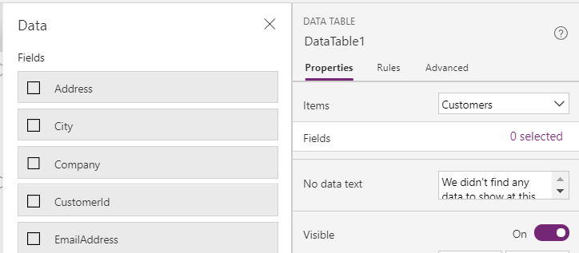

* 1. Select the fields **CustomerId**, **FirstName**, **LastName**, **Company**, **EmailAddress**, **WorkPhone** and **HomePhone**.

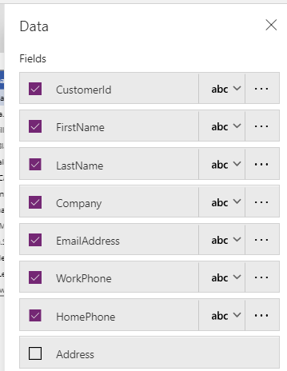

* 1. You should now see those fields appear in the Data table control.
  2. Using the mouse, resize the Data table to take up and entire height and width of the screen.
  3. Move the top of the Data table down leaving a small amount of empty space at the top as shown in the following screenshot.

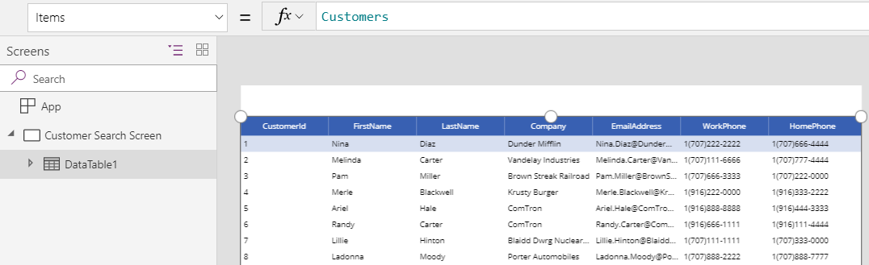

* 1. Rename the Data table control to **tblCustomers**.

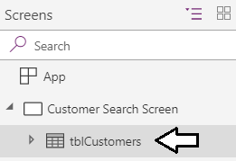

* 1. Select the **CustomerId** column and then look at this selection in the property pane on the right.

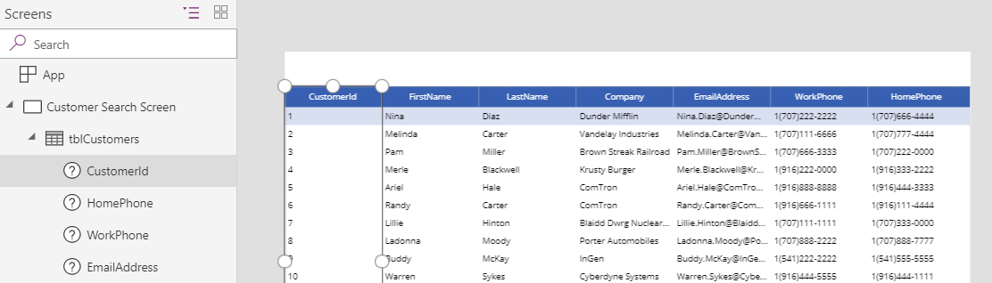

* 1. Set the **Width** property of the **CustomerId** column to **50** and set the **Can grow** property to **Off**.

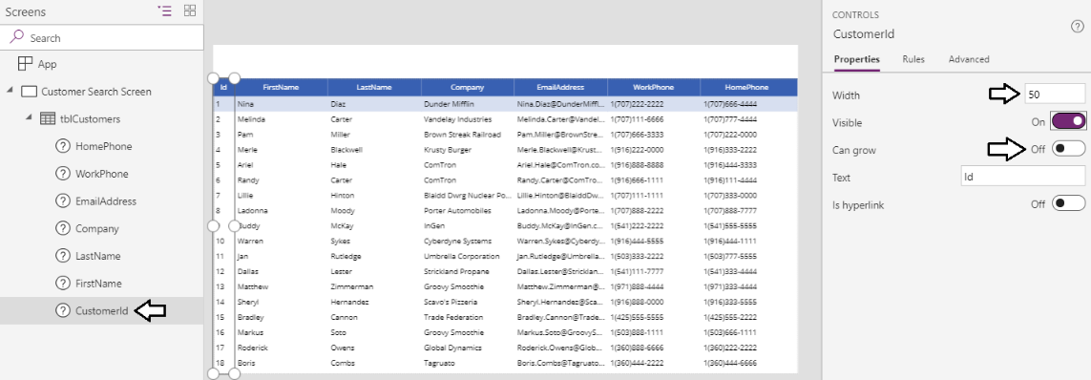

1. Add a search box
   1. Add a search icon onto the **Customer Search Screen**. and rename it to **icoSearch**.

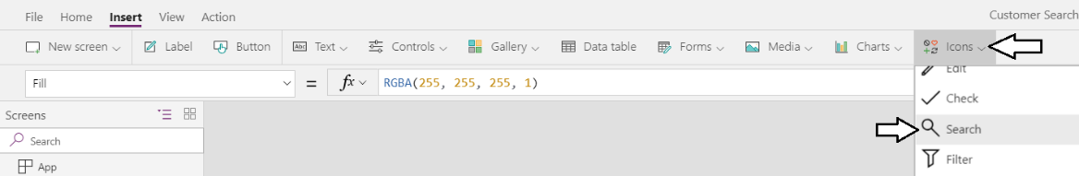

* 1. Position **icoSearch** in the upper, left as shown in the following screenshot.

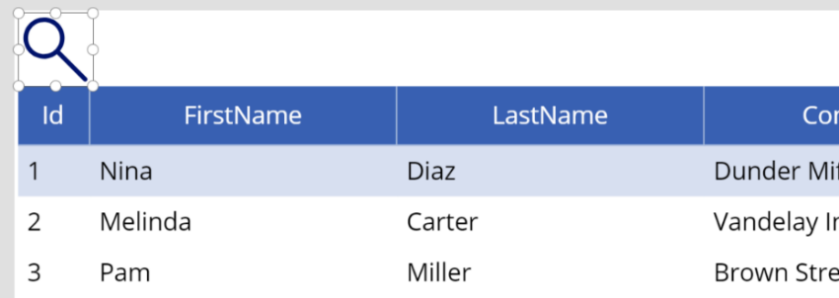

* 1. Add a **Text input** control to the **Customer Search Screen** and rename it to **txtSearchInput**.

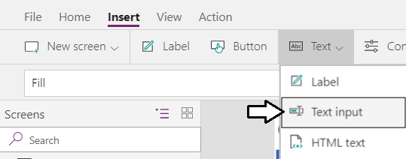

* 1. Set the **Default** property of **txtSearchInput** to **"A"**.

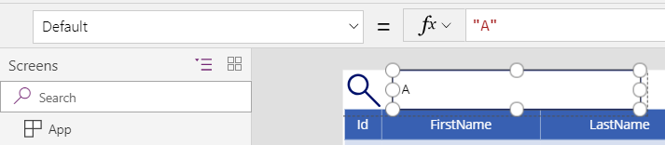

* 1. Select **icoSearch** and **txtSearchInput** together at the same time and group them using the **Group > Group** command.

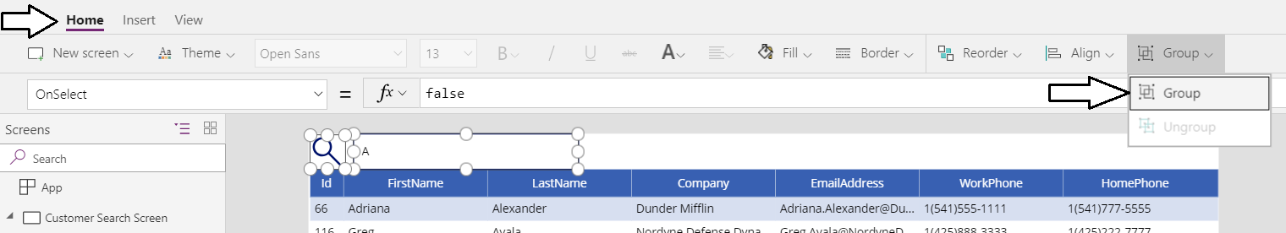

* 1. You should have created a new group named **Group1**.

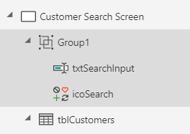

* 1. Rename **Group1** to **Search Box**.

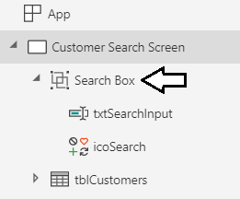

1. Add filtering and sorting behavior.
   1. Inspect the **Items** property of **tblCustomers** which should currently have a value of **Customers**.

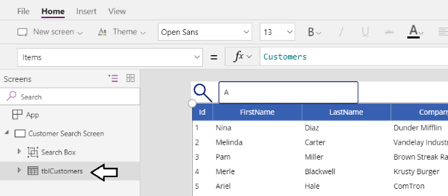

* 1. Modify the value for the **Items** property of **tblCustomers** using the following expression to add filtering behavior.

Filter( Customers, StartsWith(LastName, txtSearchInput.Text))

* 1. The items displayed by **tblCustomers** should now only include customers whose last name starts with "A".

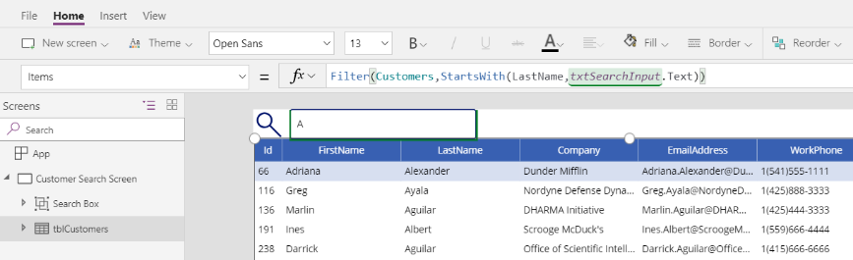

* 1. Modify the value for the **Items** property of **tblCustomers** using the following expression to add sorting behavior.

Sort(Filter(Customers,StartsWith(LastName,txtSearchInput.Text)),LastName,Ascending)

* 1. Your formula bar should match the following screenshot.



* 1. Experiment with formula formatting by dropping down the formula bar vertically and clicking the **Format text** button.

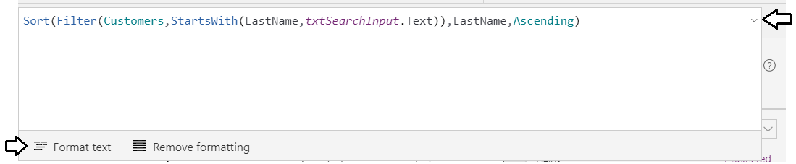

* 1. You should see that Power Apps Studio is able to format expressions to make them more readable.

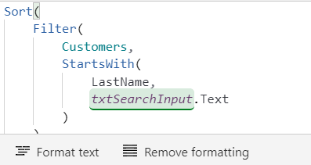

1. Test out the filter functionality
   1. Start the app and try running a search using a search input string of "Bar". You should see the following results.

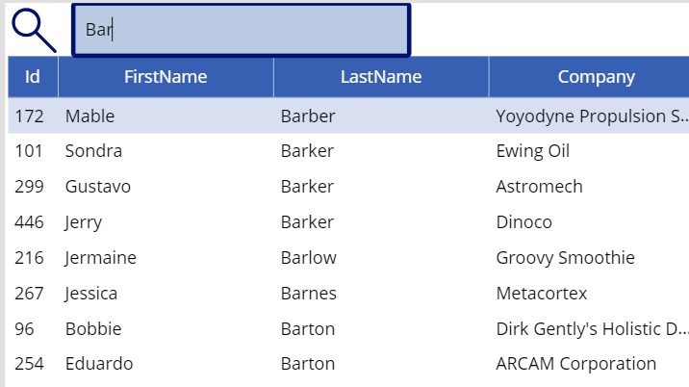

* 1. Search for "Barr" to find customers with the last name Barrera. Note that you cannot find any customers with this last name.

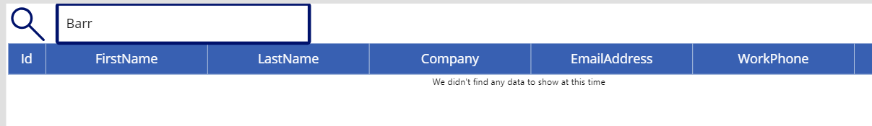

You are only searching through the first 500 records because of the way delegation works in Power Apps. You will never find any records that exist after the first 500. The key point is that you can get into trouble if you don't understand how delegation works.

1. Configure the **Customer Search** app to discover records beyond the first 500 record limitation.
   1. Navigate to Backstage area in Power Apps Studio by clicking the **File** menu.

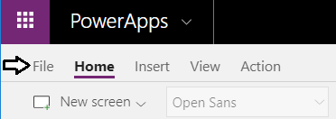

* 1. Click **App settings** in the left navigations and then click **Advanced settings**.
  2. The **Data row limit for non-delegable queries** setting should have the default value of **500**.

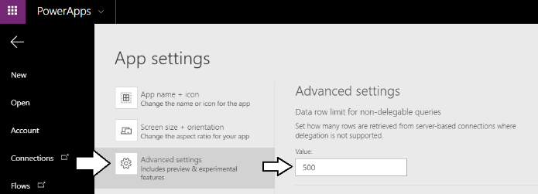

* 1. Modify the value for the **Data row limit for non-delegable queries** setting to the maximum value of **2000**.

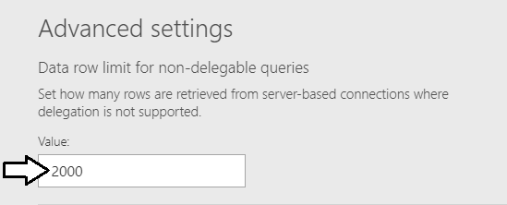

* 1. Click File to leave the Backstage area.
  2. Start up the app and run a search for **Barrera**.
  3. You should now find **Barrera** because you are looking through all the records in the underlying Excel table.

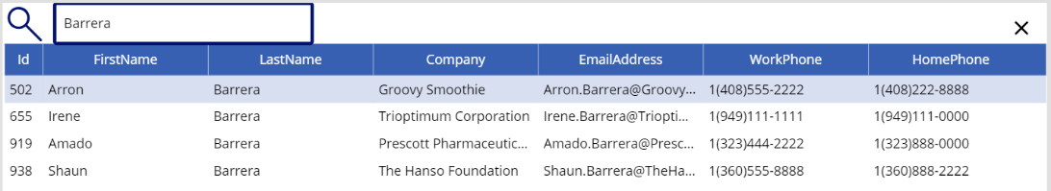

* 1. Quit the app from running and then save your changes to the app.

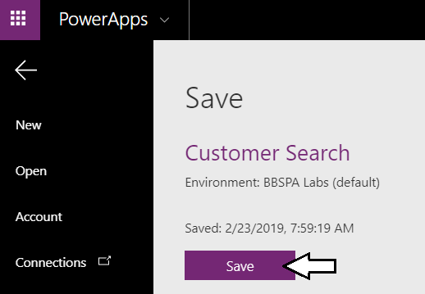

1. Student challenge (if you have time)
   1. Resize the columns in the Data table to make the data more readable.

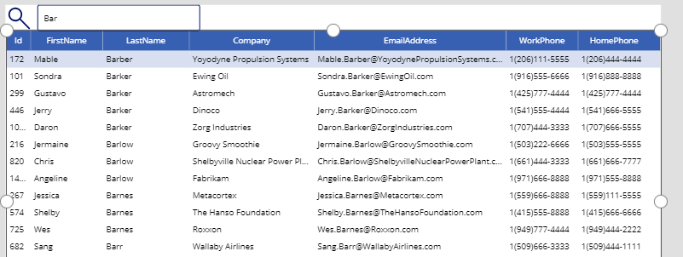

Congratulations. You have now completed this lab.